Task : 1. Create policy number 1 which lets the users to:
a. Access S3 completely
b. Only create EC2 instances
c. Full access to RDS
2. Create a policy number 2 which allows the users to:
a. Access CloudWatch and billing completely
b. Can only list EC2 and S3 resources
3. Attach policy number 1 to the Dev Team from task 1
4. Attach policy number 2 to Ops Team from task 1

- Step 1: Open AWS Console > Search IAM > Identity and Access Management (IAM) > under Access Management > Click on policies > Create policy > Select a service = S3 > Action allowed =all > Resources allowed = all.
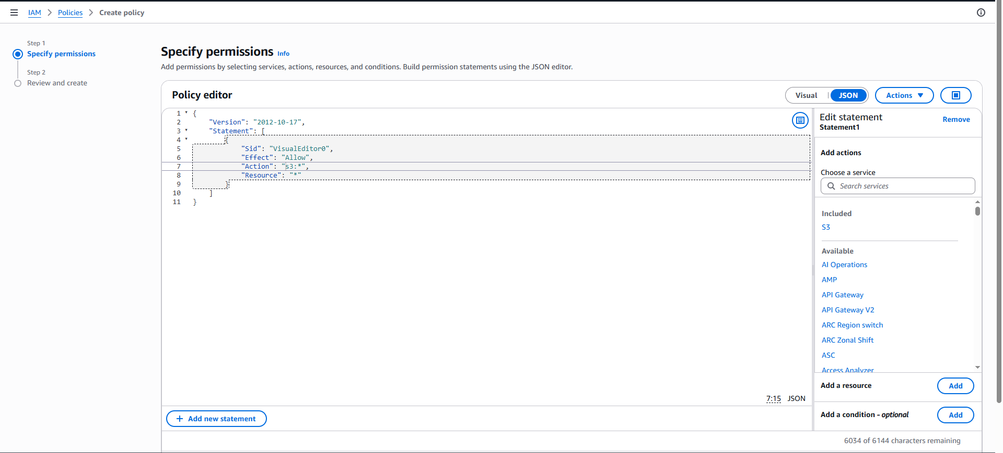
Step 2: Click on add more permissions > Service = EC2 > Action allowed > Read = DescribeInstances, DescribeImages, DescribeKeyPairs, DescribeSubnets, DescribeSecurityGroups, DescribeVpcs > write = Run instances > Resources allowed = all > Effect must be allow.
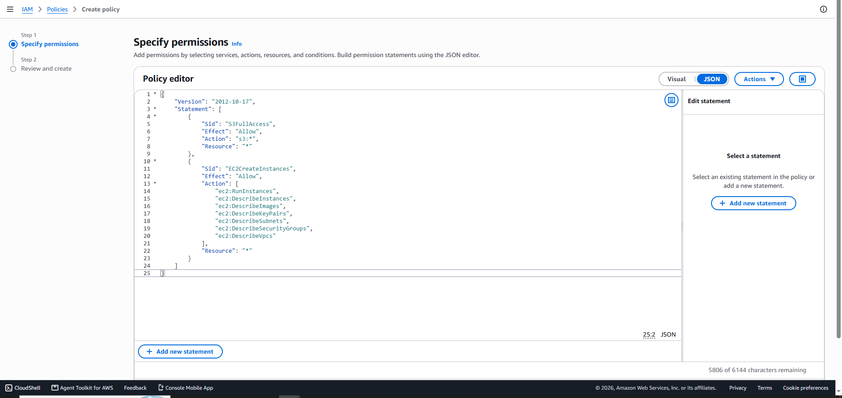
Step 3: Click on add more permissions > Service = RDS > action allowed =all and resources = all > Click on next.
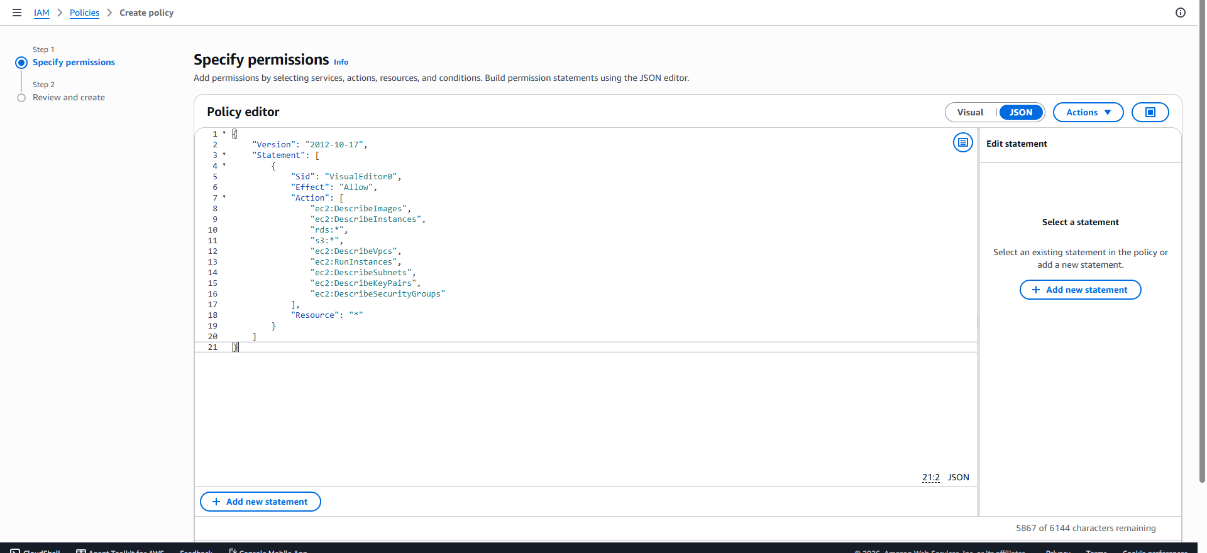
Step 4: Policy Details > Policy name = Policy-Number-1 > Click on create policy.
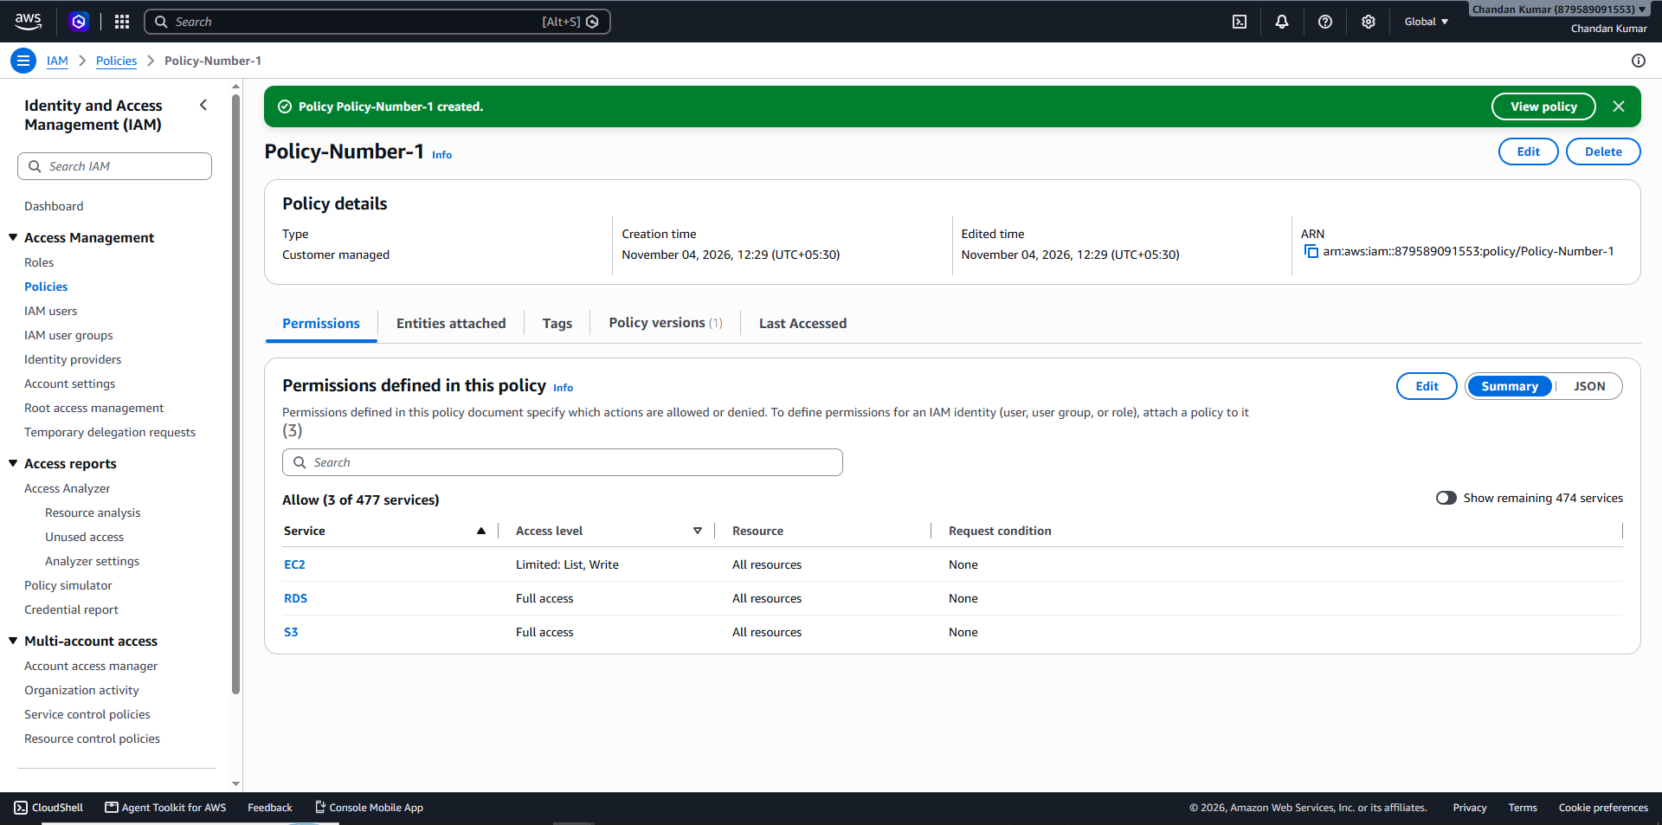
Step 5: Under Access Management > Click on policies > Create policy > Select a service = CloudWatch > Action allowed = all > resources = all.
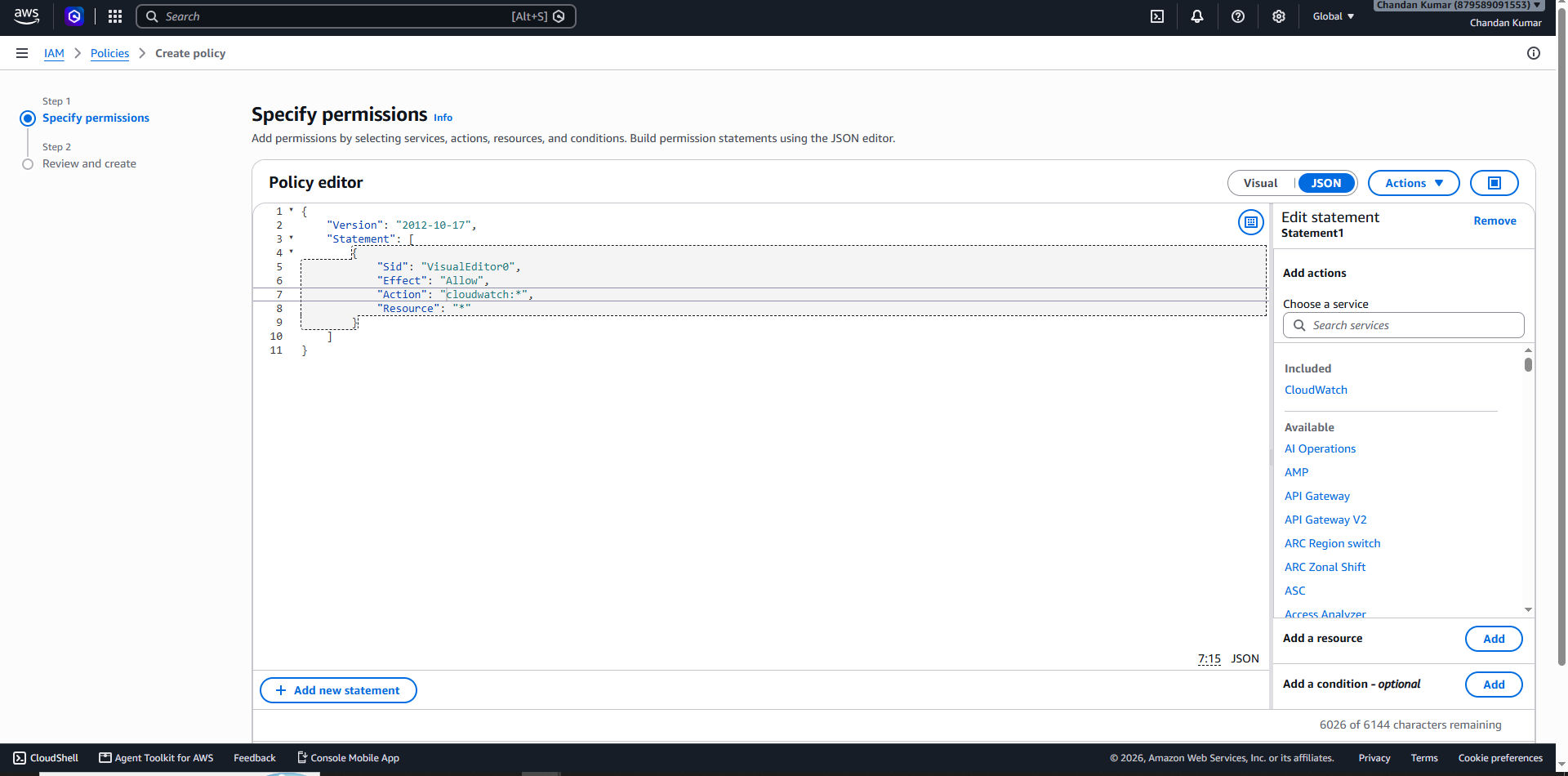
Step 6: Add more permissions > service = Billing > Action allowed = all > resources = all.
Add more permissions > service = EC2 > Actions allowed > List = describe * (using Json)> resources = all.
Add more permissions > service = S3 > Actions allowed > List = ListAllMyBuckets and ListBucket > resources = all.
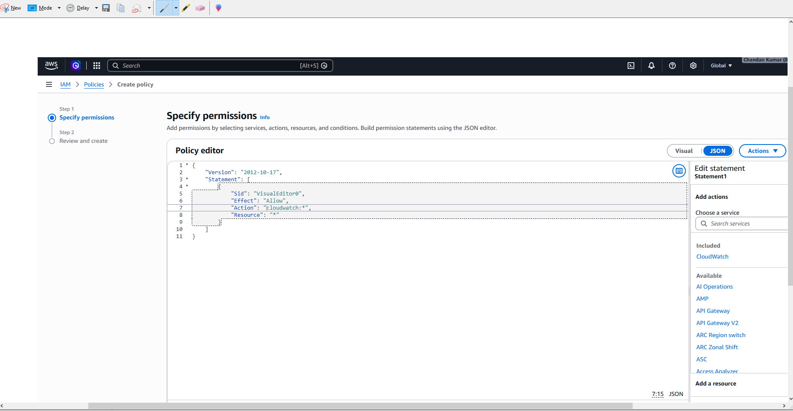
Step 7: Click on Next > Policy Name = Policynumber-2 > click on create policy.
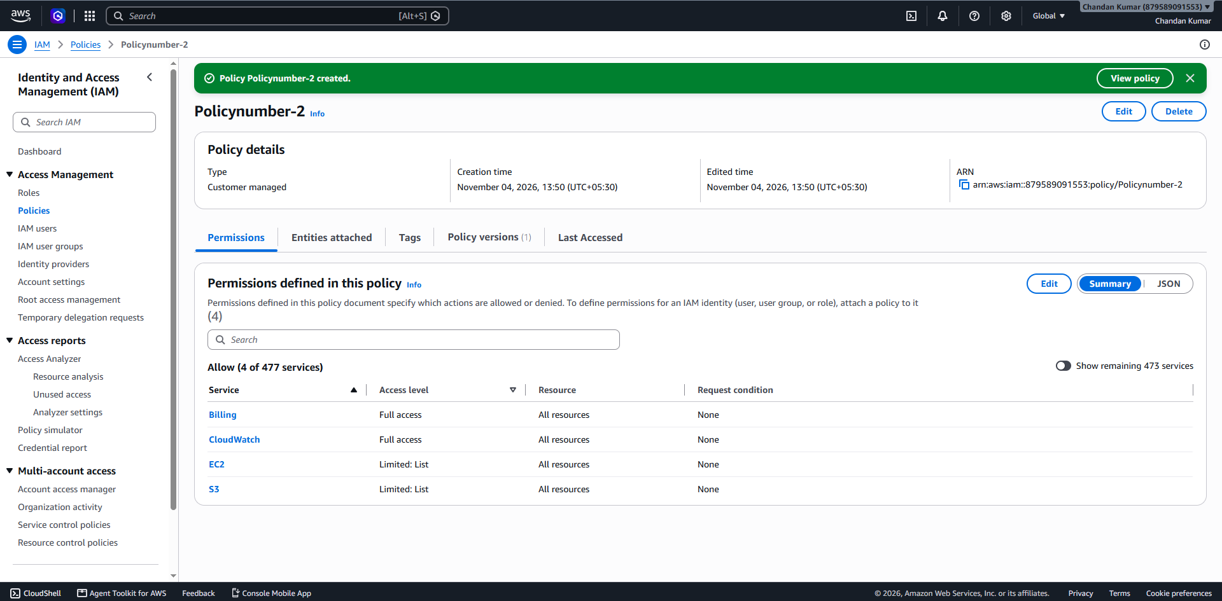
Step 8: Under Access Management > Click on IAM users group > Click on DevTeam > Permission > Add permission > Attached policies > Attach Policy-Number-1 > click on Attach policy .
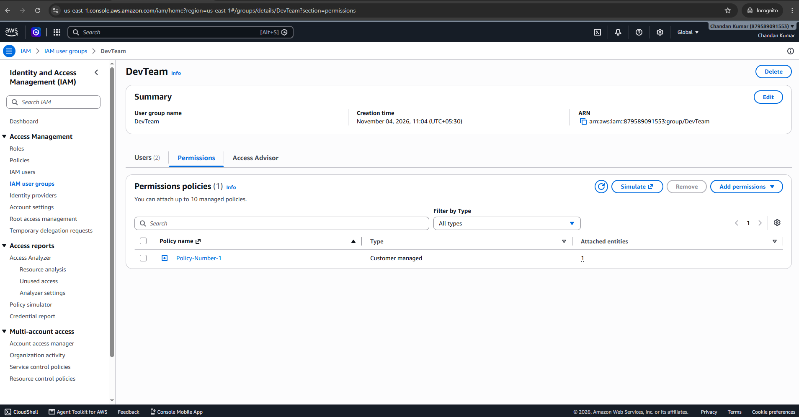
Step 9: Under Access Management > Click on IAM users group > Click on OpsTeam > Permissions > Add permission > attach policy > Click on Policynumber-2 > Click on attach policy.


